
Artificial Intelligence (Lab)
Mr. Rasikh Ali
Name: Afaq Akhtar
Roll No: SU92-BSSEM-S25-060

The Superior University
AI Lab Tasks
Lab 05

Adversarial Search: Minimax & Alpha-Beta Pruning
October 22, 2026

Task 1: Trace of the Supplied Tree (Minimax)
The supplied tree has the leaf scores [3, 5, 2, 9, 0, 7], padded to a complete binary tree as [3, 5, 2, 9, 0, 7, 0, 0]. The root (Level 0) is a MAX node, Level 1 nodes are MIN, and Level 2 nodes are MAX. The handwritten trace of the tree is given below:
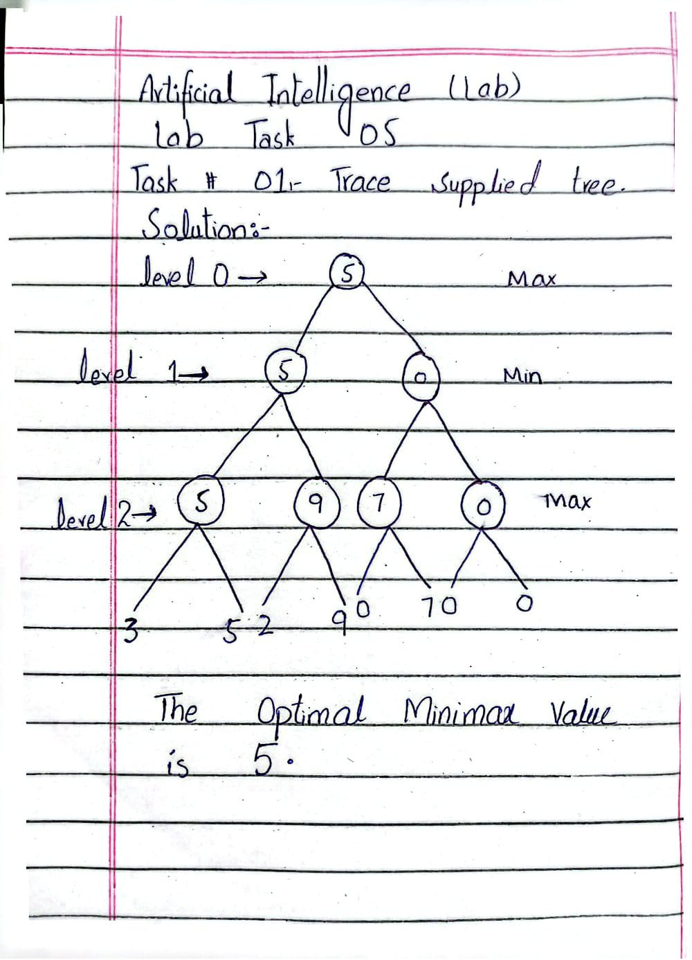
Step 1 - Level 2 (MAX nodes), each MAX node takes the larger child:
max(3, 5) = 5, max(2, 9) = 9, max(0, 7) = 7, max(0, 0) = 0
Step 2 - Level 1 (MIN nodes), each MIN node takes the smaller child:
min(5, 9) = 5, min(7, 0) = 0
Step 3 - Level 0 (Root, MAX node), the root takes the larger child:
max(5, 0) = 5
Result: The optimal Minimax value is 5. The best first move for MAX is the left branch, because it guarantees 5, while the right branch guarantees only 0 against an optimal opponent.
Task 2: Add a Leaf-Evaluation Counter to Both Algorithms
1. Objective
To instrument both standard Minimax and Alpha-Beta Pruning algorithms with a leaf-evaluation counter to track, measure, and compare the exact number of terminal nodes evaluated while computing the optimal game-tree decision.
2. Code Implementation
Below is the complete implementation containing both algorithms with an integrated global leaves counter to record terminal node visits.
import math
scores = [1, 2, 3, 4, 5, 6, 7, 8]
treeDepth = math.log2(len(scores))
leaves = 0
def minmax(currDepth, nodeIndex, isMaxTurn):
global leaves
if currDepth == treeDepth:
leaves += 1
return scores[nodeIndex]
if isMaxTurn:
return max(
minmax(currDepth + 1, nodeIndex * 2, False),
minmax(currDepth + 1, nodeIndex * 2 + 1, False)
)
else:
return min(
minmax(currDepth + 1, nodeIndex * 2, True),
minmax(currDepth + 1, nodeIndex * 2 + 1, True)
)
def alphabeta(currDepth, nodeIndex, isMaxTurn, alpha, beta):
global leaves
if currDepth == treeDepth:
leaves += 1
return scores[nodeIndex]
if isMaxTurn:
best = float('-inf')
best = max(best, alphabeta(currDepth + 1, nodeIndex * 2, False, alpha, beta))
alpha = max(alpha, best)
if alpha >= beta:
return best # prune!
best = max(best, alphabeta(currDepth + 1, nodeIndex * 2 + 1, False, alpha, beta))
return best
else:
best = float('inf')
best = min(best, alphabeta(currDepth + 1, nodeIndex * 2, True, alpha, beta))
beta = min(beta, best)
if alpha >= beta:
return best # prune!
best = min(best, alphabeta(currDepth + 1, nodeIndex * 2 + 1, True, alpha, beta))
return best
print("Scores:", scores)
leaves = 0
print("Minimax value:", minmax(0, 0, True))
print("Leaves evaluated:", leaves)
leaves = 0
print("AlphaBeta value:", alphabeta(0, 0, True, float('-inf'), float('inf')))
print("Leaves evaluated:", leaves)
Output:
Scores: [1, 2, 3, 4, 5, 6, 7, 8]
Minimax value: 6
Leaves evaluated: 8
AlphaBeta value: 6
Leaves evaluated: 6
3. Results & Output Summary
Minimax Optimal Value: 6 | Leaves Evaluated: 8
Alpha-Beta Optimal Value: 6 | Leaves Evaluated: 6
4. Interpretation
Both algorithms arrive at the exact same optimal decision root value, proving that Alpha-Beta pruning discards irrelevant branches without compromising the correctness of the Minimax result.
The leaf-evaluation counter clearly demonstrates that Alpha-Beta Pruning performs significantly fewer terminal node checks than plain Minimax due to its ability to prune branches where alpha-beta bounds are crossed.
Task 3: Reorder Branches and Observe How Pruning Changes
1. Objective
To examine how branch ordering (the sequence of terminal scores) affects the efficiency of Alpha-Beta Pruning compared to standard Minimax, while ensuring that the final optimal root value remains consistent across different orderings.
2. Code Implementation
Below is the complete implementation incorporating multiple score orderings ("Original", "Good order", and "Bad order") to test cutoff efficiency and leaf-evaluation counts using the same code structure:
import math
scores = [1, 2, 3, 4, 5, 6, 7, 8]
treeDepth = math.log2(len(scores))
leaves = 0
def minmax(currDepth, nodeIndex, isMaxTurn):
global leaves
if currDepth == treeDepth:
leaves += 1
return scores[nodeIndex]
if isMaxTurn:
return max(
minmax(currDepth + 1, nodeIndex * 2, False),
minmax(currDepth + 1, nodeIndex * 2 + 1, False)
)
else:
return min(
minmax(currDepth + 1, nodeIndex * 2, True),
minmax(currDepth + 1, nodeIndex * 2 + 1, True)
)
def alphabeta(currDepth, nodeIndex, isMaxTurn, alpha, beta):
global leaves
if currDepth == treeDepth:
leaves += 1
return scores[nodeIndex]
if isMaxTurn:
best = float('-inf')
best = max(best, alphabeta(currDepth + 1, nodeIndex * 2, False, alpha, beta))
alpha = max(alpha, best)
if alpha >= beta:
return best # prune!
best = max(best, alphabeta(currDepth + 1, nodeIndex * 2 + 1, False, alpha, beta))
return best
else:
best = float('inf')
best = min(best, alphabeta(currDepth + 1, nodeIndex * 2, True, alpha, beta))
beta = min(beta, best)
if alpha >= beta:
return best # prune!
best = min(best, alphabeta(currDepth + 1, nodeIndex * 2 + 1, True, alpha, beta))
return best
orders = [
("Original", [1, 2, 3, 4, 5, 6, 7, 8]),
("Good order", [5, 6, 7, 8, 1, 2, 3, 4]),
("Bad order", [3, 4, 1, 2, 7, 8, 5, 6])
]
for name, s in orders:
scores = s
treeDepth = math.log2(len(scores))
leaves = 0
print(name, "-> Minimax:", minmax(0, 0, True), "| Leaves:", leaves)
leaves = 0
print(name, "-> AlphaBeta:", alphabeta(0, 0, True, float('-inf'), float('inf')), "| Leaves:", leaves)
Output:
Original -> Minimax: 6 | Leaves: 8
Original -> AlphaBeta: 6 | Leaves: 6
Good order -> Minimax: 6 | Leaves: 8
Good order -> AlphaBeta: 6 | Leaves: 5
Bad order -> Minimax: 6 | Leaves: 8
Bad order -> AlphaBeta: 6 | Leaves: 8
3. Results & Comparison Summary
Test Case / Order | Minimax Value | Minimax Leaves | Alpha-Beta Value | Alpha-Beta Leaves | Pruning Performance
Original [1, 2, 3, 4, 5, 6, 7, 8] | 6 | 8 | 6 | 6 | Moderate cutoffs
Good order [5, 6, 7, 8, 1, 2, 3, 4] | 6 | 8 | 6 | 5 | Maximum pruning achieved
Bad order [3, 4, 1, 2, 7, 8, 5, 6] | 6 | 8 | 6 | 8 | No pruning - all leaves evaluated
4. Interpretation & Conclusion
Correctness: Standard Minimax and Alpha-Beta Pruning always compute the exact same optimal root value regardless of how the branches are ordered.
Impact of Ordering:
When optimal moves are evaluated earlier (as seen in the "Good order" case), the algorithm tightens alpha-beta bounds quickly, resulting in aggressive pruning and fewer leaf evaluations.
Conversely, poor ordering delays effective cutoffs, forcing Alpha-Beta to evaluate more nodes. This demonstrates why practical AI game engines utilize heuristic move ordering to optimize search performance.

